Name: ________________________________________ Date: ____________

Study Guide: Geography KEY Ms. Valdes

**Geographic Features:**

|  |  |  |
| --- | --- | --- |
| **Geographic Features** | **Positive Effects** | **Negative Effects** |
| **Rivers, Oceans, Seas** | **Easy trade, travel, fertile soil (can grow food)** | **Vulnerable to attacks (easy to invade), floods** |
| **Desert** | **Protection from invaders** | **Difficult to trade, hot, dry (arid), can’t farm (hard to travel)** |
| **Mountains** | **Protection from invaders** | **Isolated from other people, difficult to trade, travel and difficult to farm** |
| **Plains** | **Easy trade, travel, fertile soil (can grow food)** | **Vulnerable to attacks (easy to invade)** |

**Continents and Oceans:**

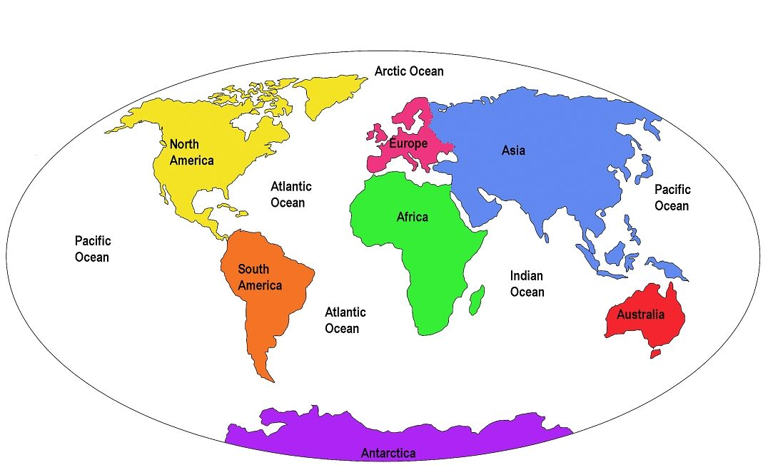

**Vocabulary:**

|  |  |
| --- | --- |
| **River** | **Archipelago** |
| **Ocean** | **Island** |
| **Continent** | **Pangaea** |
| **Desert** | **Plains** |
| **Peninsula** | **Mountain** |

1. **Island:** An area of land completely surrounded by water.
2. **Peninsula:** An area of land completely surrounded by water on three (3) sides and connected to the mainland by an isthmus.
3. **Archipelago:** A chain of islands, such as Japan and Greece.
4. **Continent:** A large body of LAND. (hint: there are seven)
5. **Ocean:** A large body of salt water. (hint: there are four main ones)
6. **Desert:** A large, arid (dry) area of land which receives less than 10 inches of rain annually.
7. **River:** A freshwater body of water which flows from a higher elevation to a lower one.
8. **Mountain:** An area that rises steeply at least 2,000 feet above sea level; usually wide at the bottom and rising to a narrow peak or ridge.
9. **Plains:** A large area of flat or gently rolling land which is fertile and good for farming.
10. **Pangaea:** The name of a huge super continent that scientists believe split apart about 200 million years ago, forming different continents.

Name: ________________________________________ Date: ____________

Geography Quiz Mrs. Valdes

**PART I**

**Directions: Fill in the chart below by listing the positive and negative effects of the listed geographic features.**

|  |  |  |
| --- | --- | --- |
| **Geographic Features** | **Positive Effects** | **Negative Effects** |
| **Rivers, Oceans, Seas** | **1.**  **2.**  **3.** | **1.**  **2.** |
| **Desert** | **1.** | **1.**  **2.**  **3.**  **4.** |
| **Mountains** | **1.** | **1.**  **2.**  **3.**  **4.** |
| **Plains** | **1.**  **2.**  **3.** | **1.** |

**PART II**

**Directions: Fill in the blanks using the appropriate word from the word bank.**

|  |  |
| --- | --- |
| **River** | **Archipelago** |
| **Ocean** | **Island** |
| **Continent** | **Pangaea** |
| **Desert** | **Plains** |
| **Peninsula** | **Mountain** |

1. **________________** An area of land completely surrounded by water.
2. **________________** An area of land completely surrounded by water on three (3) and connected to the mainland by an isthmus.
3. **________________** A chain of islands, such as Japan and Greece.
4. **________________** A large body of LAND. (hint: there are seven)
5. **________________** A large body of salt water. (hint: there are four main ones)
6. **________________** A large, arid (dry) area of land which receives less than 10 inches of rain annually.
7. **________________** A freshwater body of water which flows from a higher elevation to a lower one.
8. **________________** An area that rises steeply at least 2,000 feet above sea level; usually wide at the bottom and rising to a narrow peak or ridge.
9. **________________** A large area of flat or gently rolling land which is fertile and good for farming.
10. **_________________** The name of a huge super continent that scientists believe split apart about 200 million years ago, forming different continents.

Name: ________________________________________ Date: ____________

Geography Quiz Ms. Valdes

**PART I**

**Directions: Fill in the chart below by listing the positive and negative effects of the listed geographic features.**

|  |  |  |
| --- | --- | --- |
| **Geographic Features** | **Positive Effects** | **Negative Effects** |
| **Rivers, Oceans, Seas** | **1.**  **2.**  **3.** | **1.**  **2.** |
| **Desert** | **1.** | **1.**  **2.**  **3.**  **4.** |
| **Mountains** | **1.** | **1.**  **2.**  **3.**  **4.** |
| **Plains** | **1.**  **2.**  **3.** | **1.** |

**PART II**

**Directions: Fill in the blanks using the appropriate word from the word bank.**

|  |  |
| --- | --- |
| **River** | **Archipelago** |
| **Ocean** | **Island** |
| **Continent** | **Pangaea** |
| **Desert** | **Plains** |
| **Peninsula** | **Mountain** |

1. **________________** An area of land completely surrounded by water.
2. **________________** An area of land completely surrounded by water on three (3) and connected to the mainland by an isthmus.
3. **________________** A chain of islands, such as Japan and Greece.
4. **________________** A large body of LAND. (hint: there are seven)
5. **________________** A large body of salt water. (hint: there are four main ones)
6. **________________** A large, arid (dry) area of land which receives less than 10 inches of rain annually.
7. **________________** A freshwater body of water which flows from a higher elevation to a lower one.
8. **________________** An area that rises steeply at least 2,000 feet above sea level; usually wide at the bottom and rising to a narrow peak or ridge.
9. **________________** A large area of flat or gently rolling land which is fertile and good for farming.
10. **_________________** The name of a huge super continent that scientists believe split apart about 200 million years ago, forming different continents.